1. First create scanner object to read in input.
2. Declare variables
   1. Int I // for for loop
   2. Temp variable to hold user values
   3. Total variable to sum all numbers for average
   4. Sum2 variable to hold the sum of the squares
3. Create a for loop that will iterate through ten times
   1. Since user will input ten numbers.
   2. Prompt user to enter a number
   3. Scanner stores number in temp
   4. Sum2 holds the total of the squares in each loop iteration
   5. Total sums all the numbers in all the loops
4. Create a function that will compute the mean
   1. Print out the results of the method to the user output
5. Create a variance formula that will compute variance (since standard deviation is sqrt(variance))
   1. Take the square root of calculated variance and print it out to user output.

Test Plan validation:

|  |  |  |  |  |
| --- | --- | --- | --- | --- |
| Cases | Input | Expected Output | Actual Output | Did Test Pass? |
| Case 1 | "Enter 10 numbers." | NA | NA | Y |
| Case 2 | 1,2,3,4,5,6,7,8,9,10 | “The mean is 5.5” | “The mean is 5.5” | Y |
| Case 3 | 1,2,3,4,5,6,7,8,9,10 | “The standard deviation is 2.8722” | The Standard deviation is 2.8722813232690143 | Y |

Flow Chart:

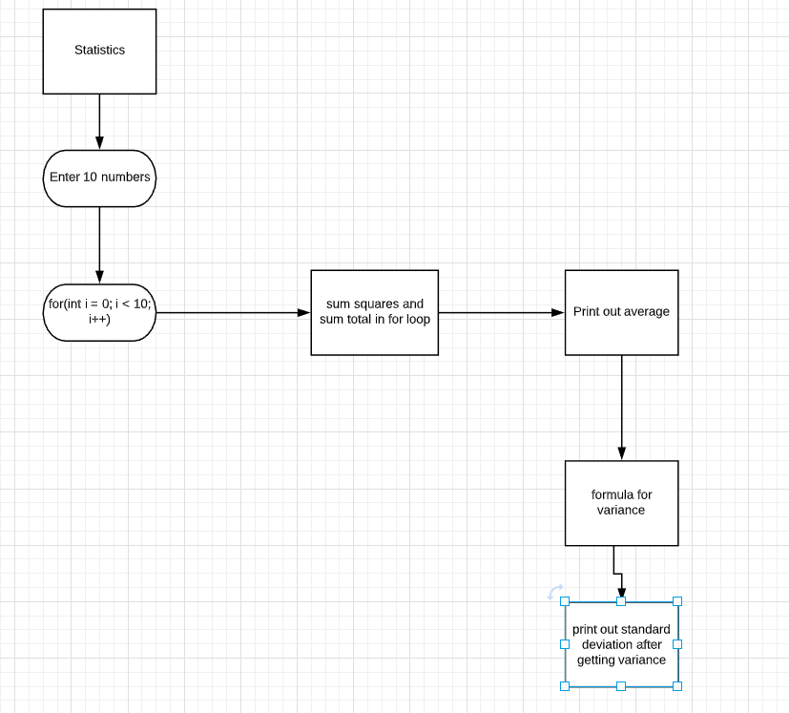

Program Screen shot:

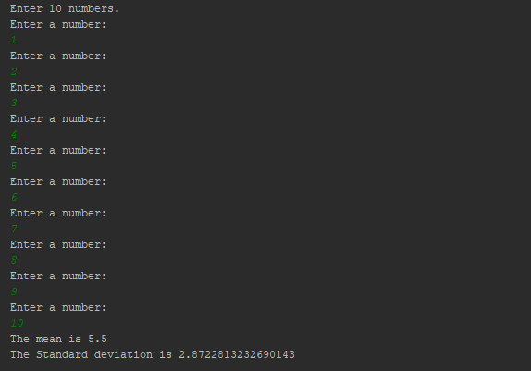

UML class diagram:

|  |
| --- |
| **Class Name:**  **Statistics** |
| **+i: int**  **+temp: double**  **+sum2: double**  **+total: double** |
| **+for(i = 0; i < 10; i++)**  **+mean(double sum, int n)** |

Lessons learned:

Figuring out how to get a easy to read formula for variance/standard deviation and code that in was the most difficult part. Simplifying and understanding variance and how it relates to standard deviation helped the most during this activity. Calculating the mean was the easy part of the activity for this project.